**Value of Analytics: Anticipatory Shipping**

**MSDS 480 (Fall 2019): Ali Gowani, Anna Zink and Ksenia Luu**

**Summary**:

Our Team was evaluating how the value of analytics **Figure 1**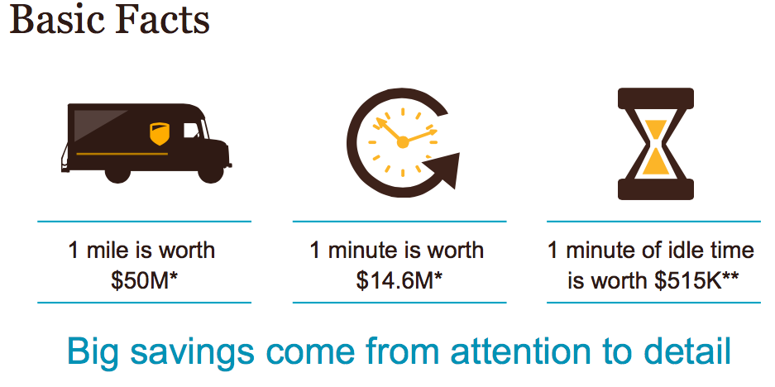

has evolved over the years and we were reminded of the Project ORION by UPS. We read a case about it during our Introduction to Data Science class. ORION was a project to optimize delivery routes for the UPS truck drivers. Any small or incremental improvement would have a significant impact on cost savings and time savings, as well as, carbon footprint (Figure 1). It made us wonder, which companies may have taken this to the next level. We figured that if routes are optimized then perhaps the next evolution would be to predict or anticipate which routes will need to be taken, even if they have not been triggered by the customer. That is when we came across a case by Amazon.

Amazon is known as an analytics powerhouse, harnessing this power to allow customers to receive their items as quickly as one day, in all corners of the world. One of the most recent advances Amazon is considering to improve their delivery times is the use of “anticipatory shipping,” in which an item would be on its way to the customer before the customer even places an order. The ideal process, diagrammed in Figure 2, would be that the item the customer hasn’t ordered yet is in “limbo” and is assigned an address while en-route, significantly cutting down on shipping time and costs compared to a product leaving a conventional fulfillment center.

In anticipation of the impact to the market and overall customer behavior, Amazon filed a patent outlining the full shipping system. The main component of “anticipatory shipping” is the data analysis of multiple “business variables” in order to predict customer demand. The prediction will then be used to route the packages in a general direction with anticipation that orders are placed to then reroute packages while in transit. The main goal of the system is to keep inventory in-transit in order to be able to fulfill orders faster. This approach to inventory management would require a complete overhaul of Amazon’s current practices. However, this initiative could help Amazon create a whole new playing field in the e-commerce space.

**Analysis:**

In this example, Amazon is utilizing the value of data analytics to increase brand recognition by gaining a unique competitive advantage over other players in the e-commerce space. Anticipatory shipping can be seen as a free value-add to the customer, making it an easy decision to choose Amazon over other e-commerce retailers. With the help of data analytics, Amazon is able to make a strategic power-play resulting in direct tangible benefits for the organization and overall impact to the e-commerce market growth.

**Tangible Benefits:**

* **Cost Savings:** implementing process of shipping items to a general predicted location and rerouting the item while still in transit can help Amazon reduce operating costs in the following areas:
  + **Shipping:** proactively shipping products allows Amazon to utilize standard shipping, which is typically ⅓ the cost of expedited shipping used for customers to receive their item in the

promised 2-day time frame. **Figure 2**

* + **Labor**: reducing the number of times a package is loaded/unloaded at different warehouse locations.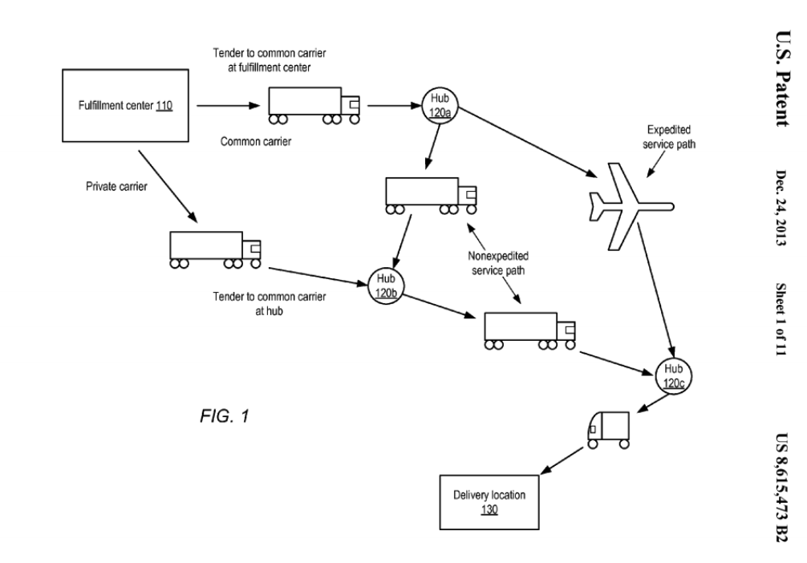
  + **Storage**: as items get routed to final destination, portion of inventory will never arrive at the warehouse. This can result in lower number of items that have to be stored at the warehouse in any given time, reducing average storage costs.
  + **Shrinkage**: lower inventory at the warehouse would result in lower shrinkage.
  + **Liquidation:** forecasting customer demand can help optimize purchasing and save on liquidation costs.
  + **Lost Sales:** forecasting customer demand can help optimize purchasing to maintain optimal stock and reduce out-of-stock windows.
* **Increase in Revenue:** Reduction of shipping time can help Amazon generate more revenue by increasing customer satisfaction
  + **Market-Share:** A further reduction in shipping speed would set Amazon apart from their main competitors, who have already adopted 2-day shipping, initially introduced by Amazon, standard. Savings in time could be seen as an added value, incentivising customers to shop with Amazon instead of their competitors.
  + **Customer Churn:** reduced speed of shipping could be seen as a reason to keep shopping with Amazon, since no other retailer can offer the same benefit. Lower customer churn results in higher customer lifetime value and increase in long-term revenue.
  + **Customer Spending:** reduction in shipping speed could incentivise customers to broaden the categories of items they buy on Amazon resulting in higher average basket size/value.
  + **Patent Licensing:** Holding the patent for “pre-shipping”, Amazon can generate revenue from companies that want to use this shipping system.
* **Impact of Decision:** 
  + **Direct impact to Amazon**: revenue and cost savings outlined in the “Tangible Benefits” section
  + **Impact to the overall e-commerce market:**  the decrease in time from point of sale to arrival at the doorstep can entice late-adopters to change their traditional shopping behavior. This could positively and negatively impact the e-commerce space with increase in shoppers, competitors, and overall evolution of retail industry norms.

**Conclusion:**

Based on our findings we would incorporate the following as key factors in Dow’s success: proactively seek the change in customer preference for their products, identify bottlenecks in the manufacturing processes, and take calculated risks in experimenting with new products. We see tremendous opportunity for analytics, which could establish a considerable gap between leaders and laggards. However, this type of separation requires enterprise-level leadership to approach analytics holistically and have the dedication to stay with it until the end. We believe The Dow Chemical Company has the right ingredients to seize the opportunity to set themselves apart from their competitors.

**References**

Lomas, Natasha. “Amazon Patents ‘Anticipatory’ Shipping - To Start Sending Stuff Before You've Bought It.” *TechCrunch*, TechCrunch, 18 Jan. 2014. <https://techcrunch.com/2014/01/18/amazon-pre-ships/>.

Spiegel, Joel R., Michael T. McKenna, Girish S. Lakshman, and Paul G. Nordstrom. Method and System for Anticipatory Package Shipping. Amazon Technologies Inc, assignee. Patent US8615473B2. 24 Dec. 2014. <https://patents.google.com/patent/US8615473B2/en>.

Eckerson, Wayne W. *Secrets of Analytical Leaders:*. Westfield, NJ: Technics Publications, 2012. Print.

Sfadavi. “Anticipatory shipping—retail’s crystal ball?.” *Harvard Business School Digital Initiative,* 15 Nov, 2018. <https://digital.hbs.edu/platform-rctom/submission/anticipatory-shipping-retails-crystal-ball/>